CANDIDATE INFORMATION SHEET
(Please fill the form in “BLOCK letters” and ensure NO field is left blank)

Personal Information

First Name (as in Aadhaar Card) |  | LANKALAPALLI |  |  | Please affix your passport size photograp 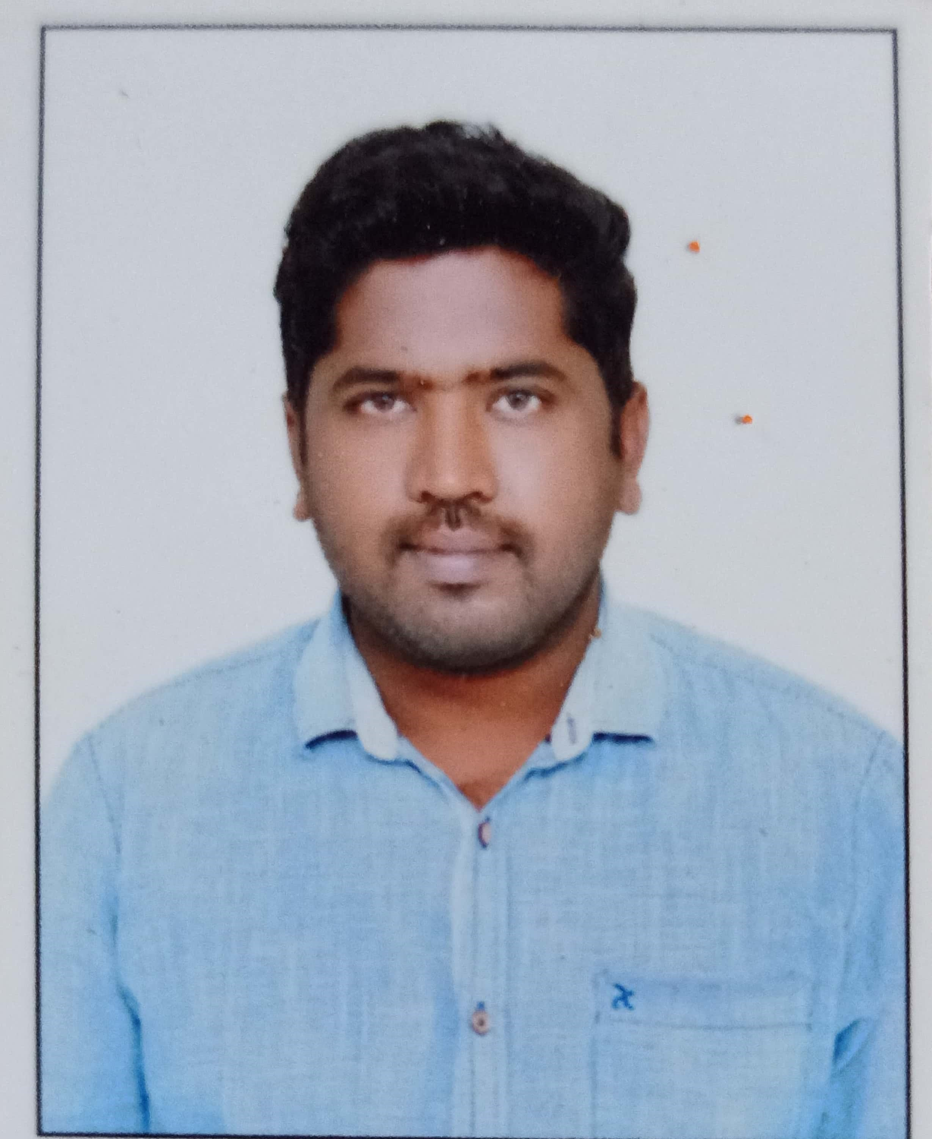 h here
Middle Name, (as in Aadhaar Card) |  | YESU
Last Name (as in Aadhaar Card) |  | BABU
Interview Date | 28/03/2024 | DOB | 12-05-1992
Address |  | H NO 1-141 RAMANAGAR COLONY  BRUNDHAVAN GARDENS  ELURU  PIN-534001
Mobile No. | +91-9493225575 | Alternate No. | +91-9160490074
Email ID 1 | y.lankalapalli123@gmail.com |  |  | Email ID 2 | lankalapalliyesubabu@gmail.com
PAN card number | AGIPL0211G |  |  | Aadhaar number | 3313 4680 5017

Work Authorization Status

Nationality |  | INDIAN | Indian Citizenship |  | YES
If you are NOT an Indian Citizen, please provide details of your India work authorization in any one of the below fields from (a) to (d):
(a) | PIO - PIO Card No. |  | Issue Date |  | Valid till
(b) | OCI – OCI No. |  | Issue Date |  | Valid till
(c) | India Employment Visa – Visa reference No. |  | Issue Date |  | Valid till
(d) | Others, if any – Please give more details

Educational Qualification

Qualification | Degree &  Specialization | School/ College Name | University Name | Full /  Part Time | % or CGPA | From (MM/YY) | To (MM/YY) | Document Available  (Yes/No)
10th / Equivalent |  | Municipal High School Eluru | Board Of Secondary Education Andhra Pradesh | FULL TIME | 62.50% | 2006 | 2007 | Yes
12th / Equivalent |  | Sri Kaatyayani Junior College-Eluru | Board Of Intermediate Education Andhra Pradesh India | FULL TIME | 71.20% | 2007 | 2009 | Yes
UG |  | Helapuri Institute of Technology and Science | Jawaharlal Nehru Technological University, Kakinada | FULL TIME | 65% | 2009 | 2013 | Yes
PG
Other Qualification

Employment History
Current Organization

S No | Organization Name | From (Date) | To (Date) | Permanent / Contract | Designation on Exit | Reason for Leaving | Supporting documents available?
1 | Accenture Solutions Private limited | 6th-May-2019 | Still | Permanent | Senior Analyst | Career aspirations and wanting a new challenges | Yes

For HR Use Only (to be filled by Infra Services & BPS candidates only)
Please confirm if you have understood the following | Signature of the Candidate
- Compensation break discussed during the HR Discussion
- The Transport boundary details and have understood it
- Willingness to work in night shifts
- Willingness to work in 24/7 shifts (For CIS only)

Compensation Details
Current Compensation |  | Expected Compensation
Fixed Pay (p.a.) | 1350000 | 25,00000
Variable Pay (p.a.) | 250000 | Remarks (If any):
Variable Payout Pattern | Half Yearly
Gross CTC (p.a.) | 16,00,000

Other Information
Last Promotion (MM / YY) | March-2022 | Last Salary Revision (MM / YY) | Dec-2023
If you are an ex - Cognizant employee, please mention your Associate ID |  |  | NO
Please mention your Notice Period [or] the date by which you can join us [whichever is earlier] |  |  | 90 Days

FOR YOUR ATTENTION
- Cognizant does not entertain payments of any kind from candidates or vendors for employment. Requests for such payments or any mails purporting to come from Cognizant seeking personal or financial details should be promptly reported to TAGCompliance@Cognizant.com
- If you encounter anyone who claims to offer jobs at Cognizant in return for any benefit (monetary or non-monetary) please do not entertain them. Please be informed that Cognizant shall not be held responsible for any such instances or payments you make
- To ascertain that you are receiving an official call from Cognizant please collect the caller’s details like full name; employee ID; and mobile number

